**Design Document | Mobile Software Development**

**Aadam Bari | C13425202 | DT228/3**

The application I hope to build for this assignment is a “Librarians Assistant” app. It would be used to help a librarian in their day to day activities and such it would have the appropriate functionality.

The functionality of the app would include the ability to:

1. Add new book into database (INSERT)
2. Borrow a book (UPDATE [the number of copies of a book available])
3. Search books by author or name (SELECT)
4. Delete books from database (DELETE)

**Screen Flow**

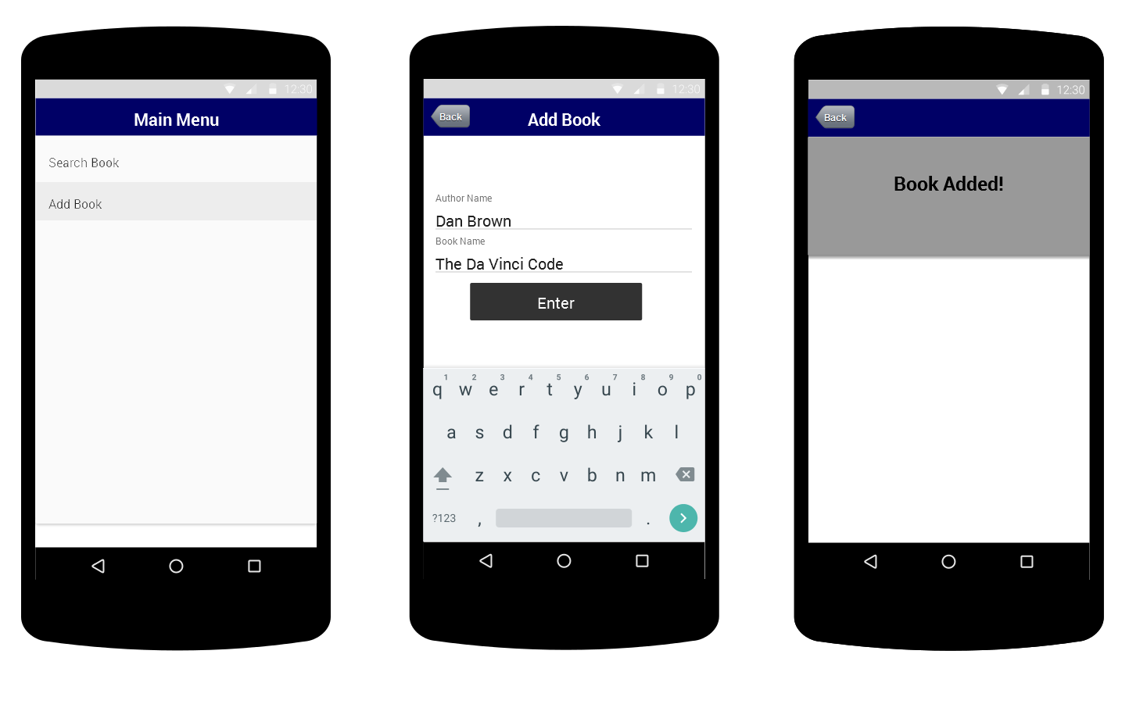

Here you can see the Main Menu on the left, this will be the first screen of the app.

You have the option to either search or add a book.

(Middle) Add book is selected and then the user has the ability to add a book to the database, giving the entry a book name and an author name.

(Right) The action is confirmed as successful

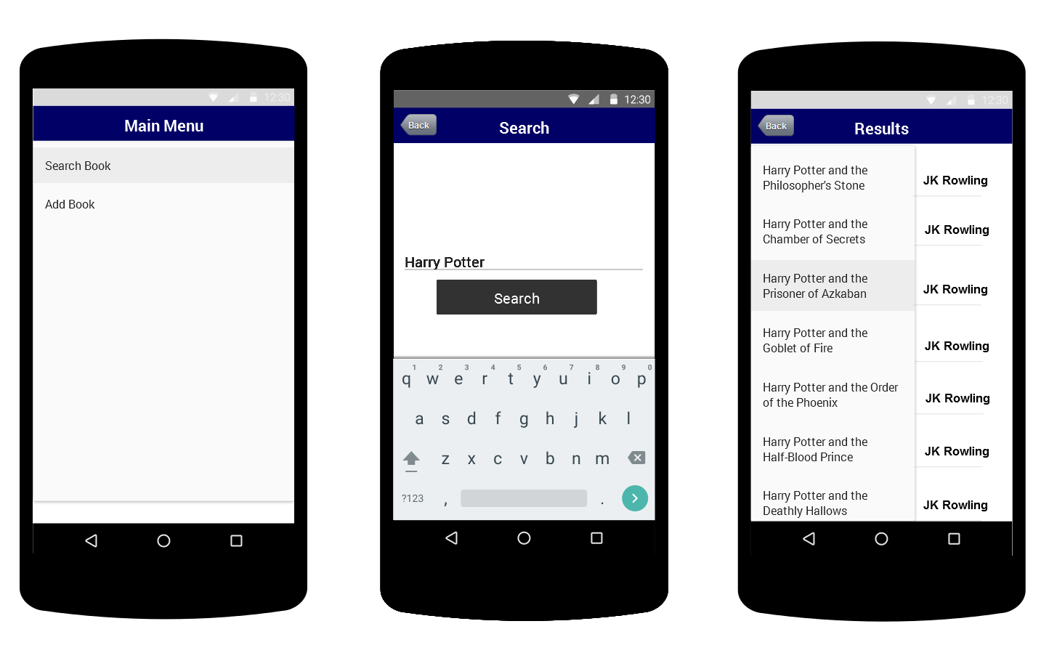

Search book is selected from the main menu (left).

A book can be searched for on the second screen (middle).

The right screen displays the results from the search.

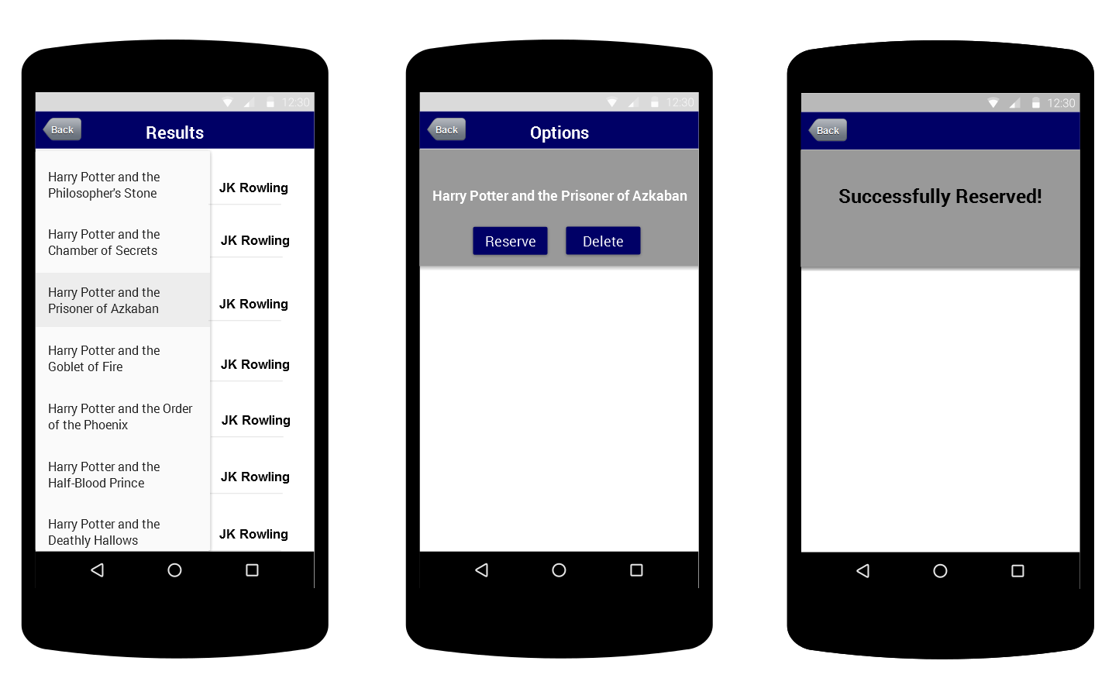

After a book is selected from the search results list (left), the options to either reserve or delete the book are offered (middle). The right screen will display the confirmation of the actions.

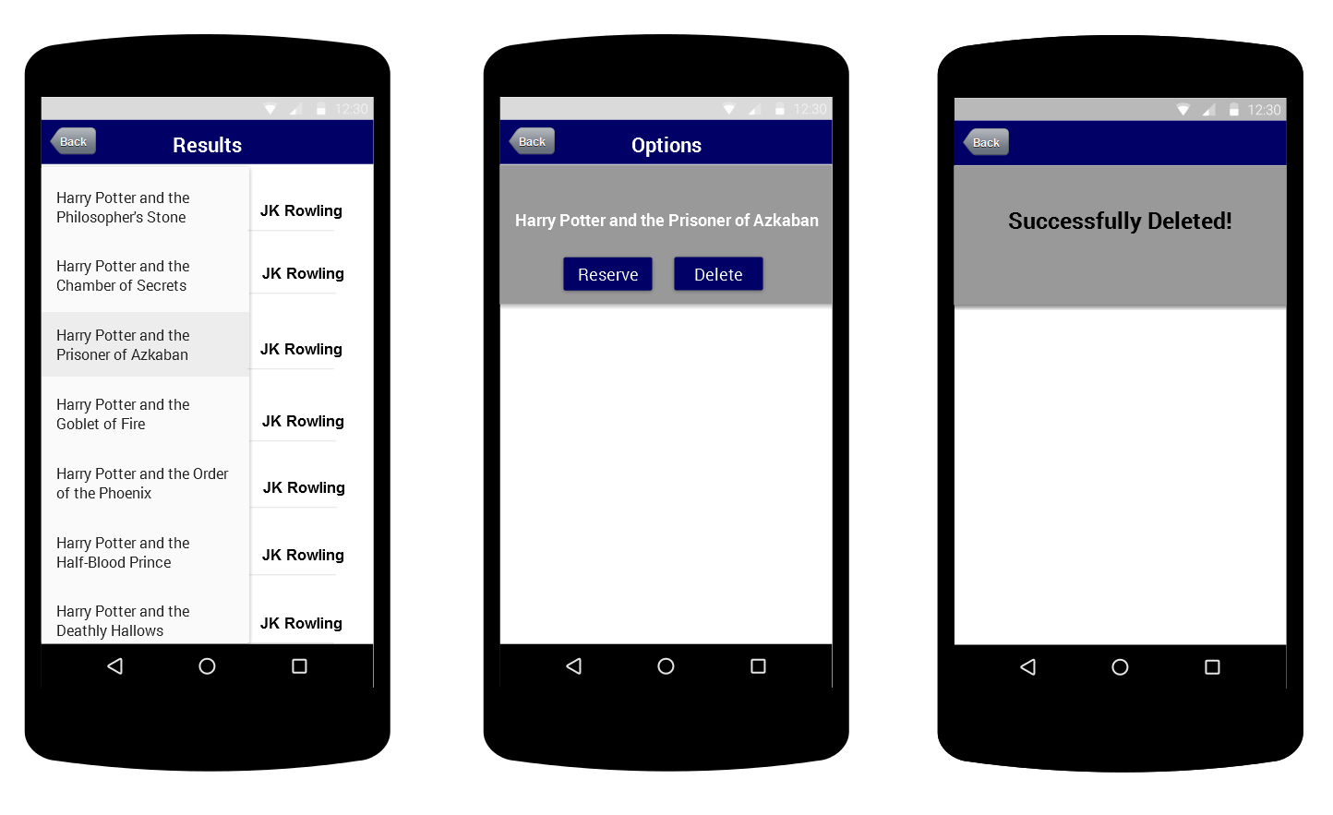

**Use Case Diagram**

The Use Case diagram for my app

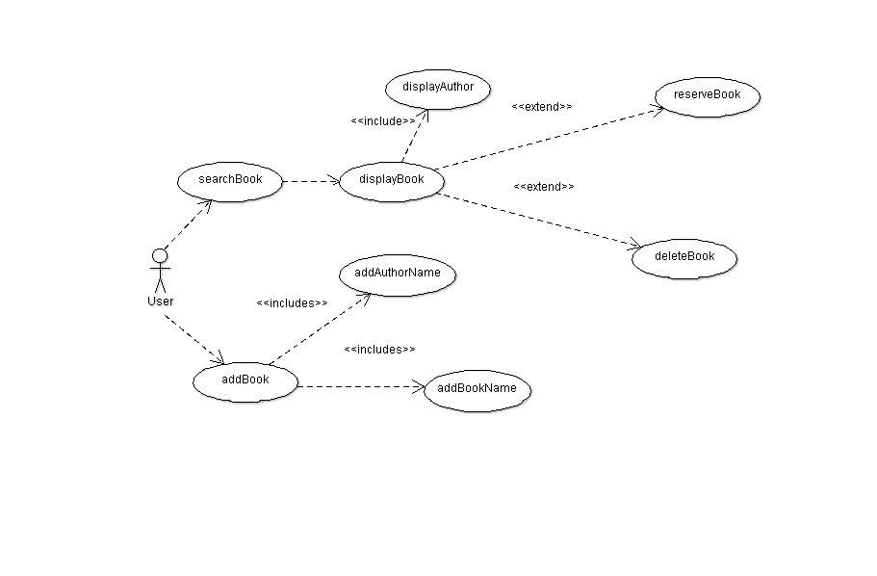

**Database Description**

My database for the app will contain just one table named Book.

Each book will have an individual ID, an ID for the author of the book, the author name, the book name and the number of copies of the book available.

The BookID would be the only primary key.

The regular fields would be AuthorID, AuthorName, BookName, Copies.

**Book** - (BookID, AuthorID, AuthorName, BookName, Copies)